User Guide
For POS-Inventory
Management System

“FOUR ACC Angel’s Bakeshop”

St4nger Dev. @2025

Four ACC Angel’s Bakeshop

POS-Inventory Management System
Efficiently manage your bakery's inventory, sales,
and
products with our comprehensive system.
Characterize in different features:

Product Management

Sales Tracking

Reporting

Inventory Tracking

Receipt Generation

Sales Analytics

St4nger Dev. @2025

Product Management
Add, edit, and manage your bakery products with ease. Track inventory levels and receive alerts when stock is low.
• Categorization – Organize breads, cakes, pastries, and other items by type for easy tracking.
• Pricing Control – Set and update product prices, discounts, and markups to reflect costs and promotions.
• Stock Monitoring – Keep real-time records of available products and automatically flag low-stock items.
• Batch & Expiry Tracking – Record baking dates and shelf-life to ensure product freshness.
• Product Availability – Instantly check if an item is available before processing a sale.
• Image & Description Management – Upload product photos and details for better product identification.
• Seamless POS Integration – Ensure products are directly linked with the sales system for accurate billing.

Sales Tracking
Monitor your sales, generate receipts, and keep track of transactions with our point-of-sale system.
- Real-Time Transaction Recording – Every sale is automatically logged into the system.
- Customer Receipts – Generate printed or digital receipts for each purchase.
- Daily Sales Summary – View total sales, product breakdowns, and peak selling hours.
- Cashier Accountability – Track sales by cashier to ensure accuracy and responsibility.
- Discounts & Promotions – Apply discounts and special offers directly during checkout.
- Refunds & Returns – Manage product returns with proper documentation for transparency.
- Payment Methods – Support cash, digital wallets, or card payments for flexibility.

Reporting
Generate detailed reports on sales, inventory, and profitability to make informed business decisions.
- Sales Reports – Track daily, weekly, and monthly sales to identify best-selling products.
- Inventory Reports – Monitor stock levels, wastage, and expired items to maintain efficiency.
- Profit & Loss Analysis – Evaluate revenue vs. expenses to measure overall profitability.
- Trend Analysis – Identify seasonal demand and customer buying patterns.
- Customizable Filters – Generate reports by date range, product type, or category.
- Export Options – Save reports in PDF, Excel, or Word for presentations and records.
- Decision Support – Use data insights to plan promotions, restocking, and pricing strategies.

Inventory Tracking
Real-time tracking of your bakery items to ensure smooth operations and reduce losses.
• Stock Updates – Automatically update item counts when products are sold, added, or returned.
• Low-Stock Alerts – Receive instant notifications when ingredients or products reach critical levels.
• Expiry & Shelf-Life Monitoring – Track perishable goods to minimize waste and maintain quality.
• Batch Control – Record production batches for easier monitoring of baking schedules.
• Supplier Management – Keep records of suppliers for quick reordering when stock is low.
• Storage Insights – Monitor ingredient and finished product levels across different storage areas.
• Audit Trail – Maintain a history of stock adjustments for accountability and accuracy.

Receipt Generation
Professional receipts for your customers, ensuring accuracy and a smooth checkout experience.
- Automatic Receipt Printing – Instantly generate receipts after each transaction.
- Custom Branding – Add your bakery’s logo, name, and tagline to every receipt.
- Detailed Breakdown – Show itemized purchases, quantities, prices, discounts, and tax.
- Multiple Formats – Provide printed receipts or digital copies (email/SMS) for convenience.
- Unique Transaction IDs – Assign reference numbers for tracking and verification.
- Return & Warranty Info – Clearly display return policies or product guarantees.
- Eco-Friendly Options – Reduce paper use with digital receipts when possible.

Sales Analytics
Understand your business performance with insights that drive growth and efficiency.
- Revenue Tracking – Monitor daily, weekly, and monthly income trends.
- Top-Selling Products – Identify your best-performing items to focus on customer favorites.
- Customer Insights – Analyze buying habits, peak hours, and repeat purchases.
- Profit Margins – Compare costs and sales to measure profitability per product.
- Visual Dashboards – Use charts and graphs for clear, easy-to-read analytics.
- Forecasting – Predict future sales trends to plan inventory and production.
- Performance Comparison – Evaluate sales across time periods, branches, or categories.

Introduction to Development Tools
This project was developed using a combination of web technologies and frameworks that collectively form both the frontend and backend components of the system. The frontend was primarily built using HTML, CSS, and JavaScript, which provided the foundation for designing an interactive and user-friendly interface. HTML was utilized to define the structure and content of the pages, CSS was applied to ensure consistency in design and responsiveness across different displays, while JavaScript introduced dynamic features such as input validation, modal interactions, and real-time updates.
On the backend, PHP was employed as the server-side scripting language, enabling seamless interaction with the database and efficient handling of operations such as product management, sales recording, and inventory tracking. PHP was chosen for its simplicity, reliability, and wide adoption in web-based application development.
To transform the web-based system into a desktop application, the project was integrated with Node.js and Electron. Node.js provided the runtime environment for executing JavaScript outside of the browser, while Electron enabled the packaging of the system into a cross-platform desktop application. This approach allowed the system to retain the flexibility of a web application while also providing the convenience and accessibility of a standalone program.
Through the integration of these technologies, the project successfully combines the strengths of frontend design, backend logic, and desktop deployment, resulting in a comprehensive and efficient POS–Inventory Management System tailored for bakery operations.

Technology Stack
This project was developed using a combination of web and desktop technologies:
- HTML, CSS, JavaScript – For building the user interface, styling, and adding interactivity.
- PHP – For backend processing and database interaction, managing sales, products, and inventory.
- Node.js & Electron – To package the system into a cross-platform desktop application, combining the flexibility of web development with the convenience of a standalone program.
Together, these tools ensured the creation of a user-friendly, efficient, and reliable POS–Inventory Management System tailored for bakery operations.

Backup and Data Security
To ensure the reliability and integrity of the POS–Inventory Management System, a backup mechanism was incorporated as part of the project design. Since the system relies on a database to manage products, inventory, sales, and user transactions, it is essential to safeguard this information against accidental loss or corruption.
The backup process is handled through the backend using PHP and MySQL tools. Database records can be exported into structured .sql files, which serve as restorable copies of the system’s data. These backups can be performed manually by administrators or automated through scheduled scripts. In addition, application files such as HTML, CSS, JavaScript, and PHP scripts can be copied to secure storage to preserve system functionality.
By integrating backup and recovery procedures, the system provides not only efficiency in daily operations but also resilience against data loss, ensuring that critical business information can be restored promptly whenever needed.
Guide for Configuration:
The successful deployment of the POS–Inventory Management System requires proper configuration of both the development environment and the application runtime. The following steps outline the recommended configuration process:

1. System Requirements
- Operating System: Windows 10 / 11 (64-bit) or Linux equivalent
- Processor: Dual-core or higher
- Memory: Minimum 4 GB RAM
- Storage: At least 50 GB free space
- Dependencies: XAMPP (for PHP and MySQL), Node.js, Electron

2. Backend Configuration
- Install XAMPP and start the Apache and MySQL services.
- Place the project files inside the htdocs directory of XAMPP (C:\xampp\htdocs\Store).
- Import the project’s database file (store.sql) into phpMyAdmin to automatically create the schema and tables.
- Update the database connection file (dbconn.php) with the correct database credentials:
  - Hostname: localhost
  - Username: root (default)
  - Password: (leave blank unless modified) or this “”
  - Database: (Store)

3. Frontend Configuration
- Ensure all HTML, CSS, and JavaScript files are correctly linked within the project structure.
- Verify that paths for external libraries (Bootstrap, SweetAlert, Chart.js, etc.) are correctly set, either via CDN or locally.
- Customize the UI components (logos, labels, and colors) to match the bakery’s branding.

4. Application Packaging (Electron)
- Install Node.js (latest LTS version recommended).
- Initialize the project using:
- npm init
- Install Electron:
- npm install electron --save-dev
- Configure the main.js file in Electron to load your PHP-based system via a local server (Apache in XAMPP).
- Run the application with:
- npm start
- Package the application for distribution (optional):
- npm run build

5. Testing & Validation
- Verify product management, sales tracking, and reporting modules.
- Test receipt generation with both sample and real transactions.
- Check inventory alerts by simulating low stock levels.
- Ensure reports generate correctly and export as expected.

6. Maintenance & Updates
- Regularly back up the database to prevent data loss.
- Apply updates to PHP, Node.js, and Electron for security and performance.
- Document any customizations for future development or debugging.

User Guide
This section provides instructions for end-users on how to operate the POS–Inventory Management System efficiently. The guide covers essential modules, navigation, and step-by-step usage of key features.

1. Logging In
- Launch the application by running the Electron-based executable file.
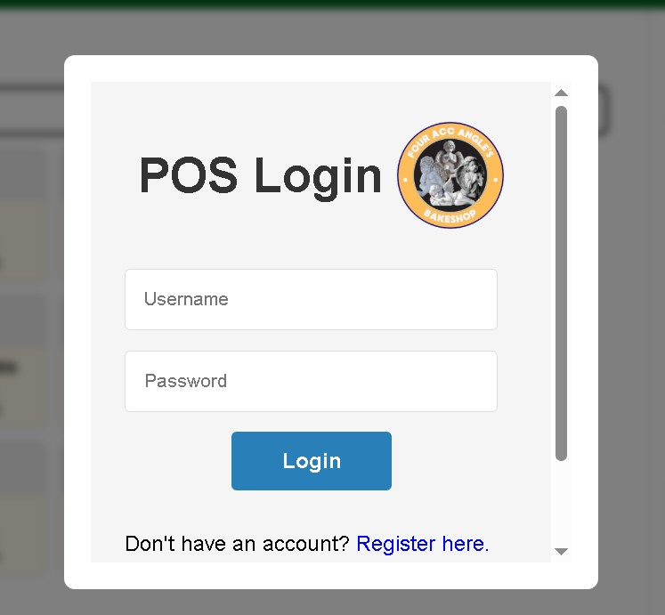
- Enter your assigned username and password in the login screen.
- Upon successful login, the system dashboard will be displayed.

2. Sign Up
New users, such as cashiers or administrators, must first register to gain access to the system. The Registration Page allows secure account creation by requiring the following information:
• Logo & Header – The system displays the bakery’s logo and a “Register Here” title for identification.
• Username – A unique identifier used to log in to the POS system.
• Full Name – The user’s complete name for record-keeping.
• Email – Contact information for account verification and notifications.
• Cashier – The role designation (e.g., cashier or staff).
• Password – Must contain at least 8 characters to ensure account security.
• Confirm Password – Re-enter the password to verify correctness.
• Registration Key – A special access key provided by the system administrator to prevent unauthorized sign-ups.

Action Buttons:
- Register – Submits the registration form and creates a new account if all inputs are valid.
- Login here – Redirects users who already have an account to the Login page.
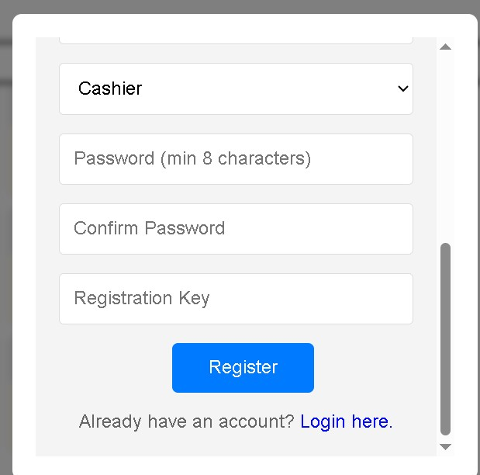
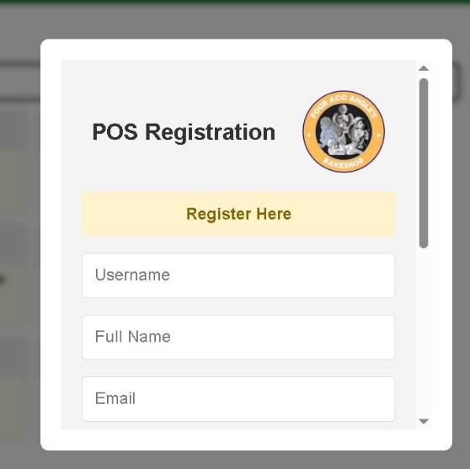

After successful registration, users can proceed to the Login module to access the system.

